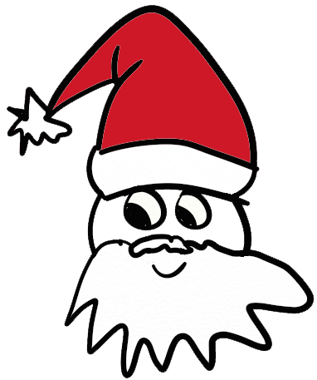
Santa got his Christmas elves to create a math puzzle just for you!

Work through each piece and when you get to the end, the final number has a special meaning.

Pick a number between 1 and 20.
Multiply it by PUT_NUMBER_HERE.
Add NEXT_NUMBER_GOES_HERE.

Multiply the result by ANOTHER_NUMBER_HERE.
Add to that ALMOST_THE_LAST_NUMBER_HERE.
Divide by ONE_LAST_NUMBER_HERE.
Subtract from that your original number.

And guess what that number is?!
Merry Christmas!

Scratch Space

