Discovery Toys Playful Bath Shapes
Activity Questions

You can label the bathtub tiles with soap crayons so you can discuss the patterns more easily. Use the Cartesian Coordinate plane or Excel cell names like I did in Photoshop in this picture:

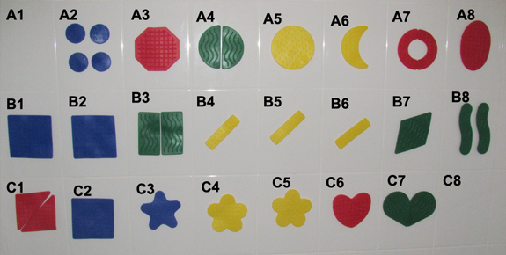

Here are some things to talk about to encourage pattern discovery and learning:
- Which shapes are similar? Which are congruent?
- Which shapes are kind of the same (similar, but not in the official math sense of “similar”)
- Put shapes together that “go together” – these could be same shape, color, “feel” (like B6 and B7 are both angled).
- Compare shape A5 to the shapes A3, A4, A6, A7 and A8.
- What do cells B3 and B8 have in common?
- How are C3 and C4 different?
- What’s in common in cells A2 and B2?
- How are shapes C1 and C2 different?
- How are C2 and B3 similar?

Buy the shapes here or on www.DiscoveryToysLink.com/MathFour in the catalog.

Learn more about Discovery Toys and math on…


